Skill Week 9
Aim
To learn how to list active background jobs, display their status, identify job IDs and process IDs, and monitor the current state of jobs in Linux.
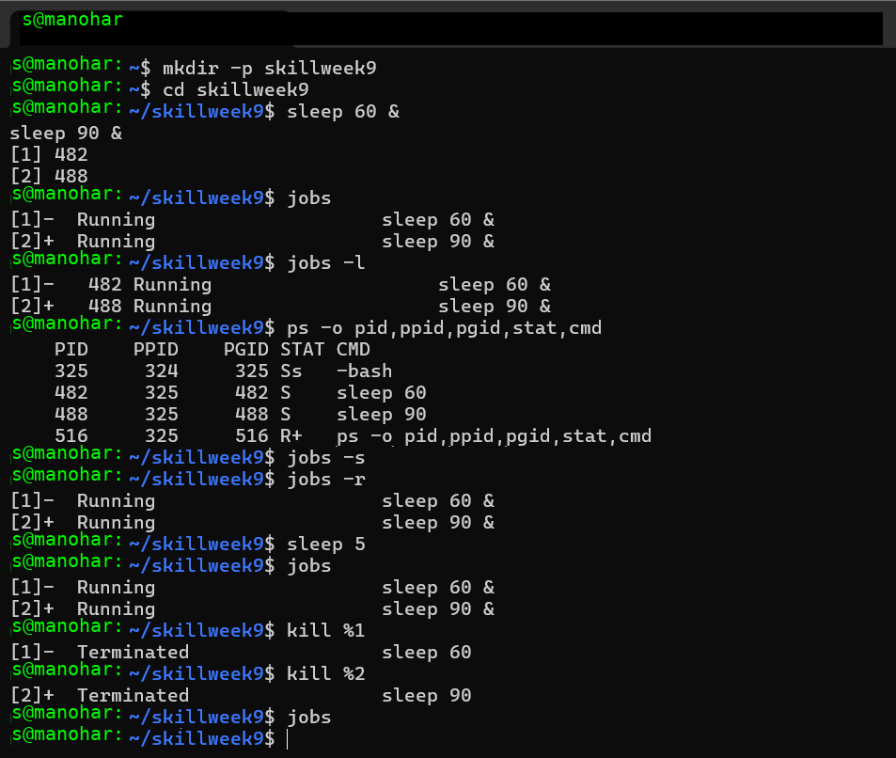
Observation
The jobs command lists background jobs and their states. The jobs -l command provides additional information such as the process ID. The ps command displays detailed process information.
Result
Active background jobs were successfully listed, identified, monitored, and terminated using Linux job-control commands.

Aim
To learn how to identify a background job, bring it to the foreground, transfer terminal control, resume a stopped process, and wait for the process to complete.
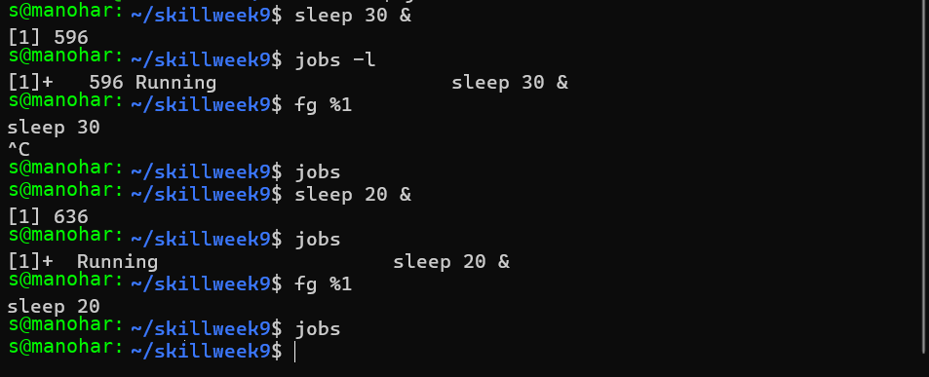
Observation
The jobs command identifies active jobs, while fg transfers a background job to the foreground and gives it terminal control. Ctrl + C interrupts the foreground process. After a process completes, it is removed from the active job list.
Result
Background jobs were successfully identified, transferred to the foreground, monitored, interrupted, and completed using Linux job-control commands.

Aim
To understand how Linux signals are delivered to processes, how terminal signals such as SIGINT and SIGSTOP affect processes, and how to observe signal behavior using process-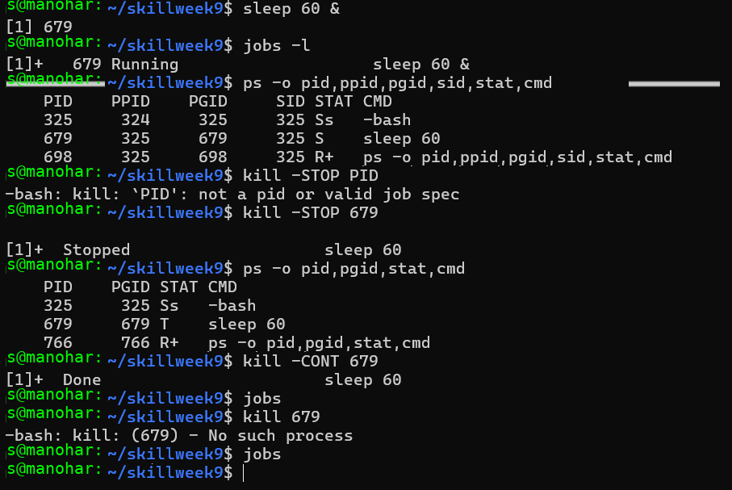
Observation:
The system reports No such process because PID 679 no longer exists.
Result:
The process has already ended, so no further kill command is needed.

Aim
To learn how to resume a stopped background job using SIGCONT, check its status, and verify that the job continues execution successfully.
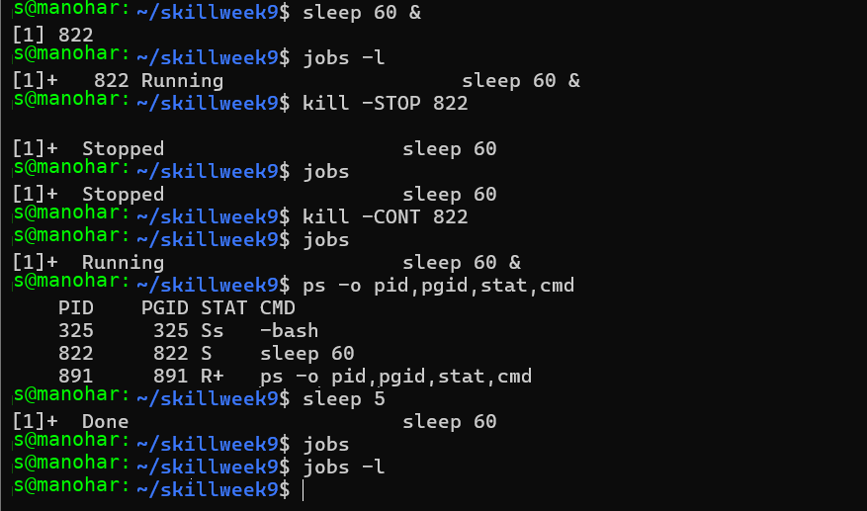
Observation
The background process was stopped using SIGSTOP and successfully resumed using SIGCONT. The jobs command showed the change from Stopped to Running.
Result
The stopped background job was successfully resumed, monitored, and verified using SIGCONT and Linux job-control commands.

